**Qualitative analysis task**

**Question: “Which parts of the course did you find most useful? Why?”**

Students were given a list of 24 responses to a qualitative survey and asked to analyse (refer to slide 7 for instructions and Excel file).

After some time to work on the task, we wrote the themes that students came up with on the whiteboard. The photo from this stage is below:

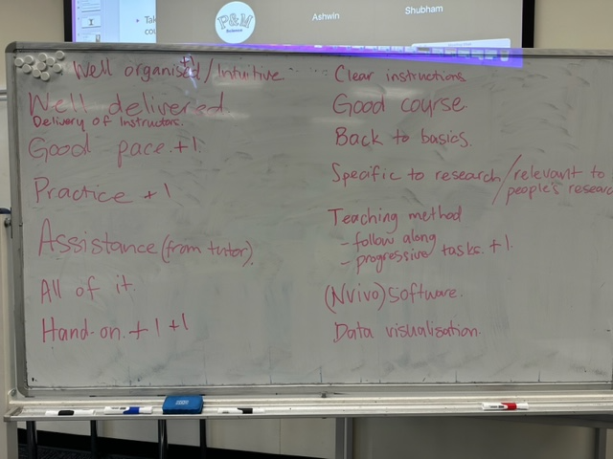

Then we grouped these themes into larger concepts. Students were advised that all 24 responses could be categorised in one of 4 possible concepts.

The first concept that was identified was ‘All of it.’ While not a larger concept per se, there were many responses that advised that all of the training course was good, so that was counted as one concept.

The other concepts are colour coded: Course Design in blue; Teaching Style in purple.

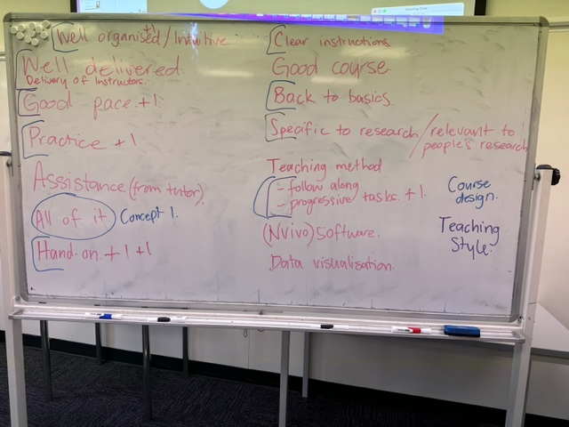

The Excel spreadsheet has a colour coded ‘answers’ tab.